Masks and Mumming in the Nordic Area
ed. Terry Gunnell

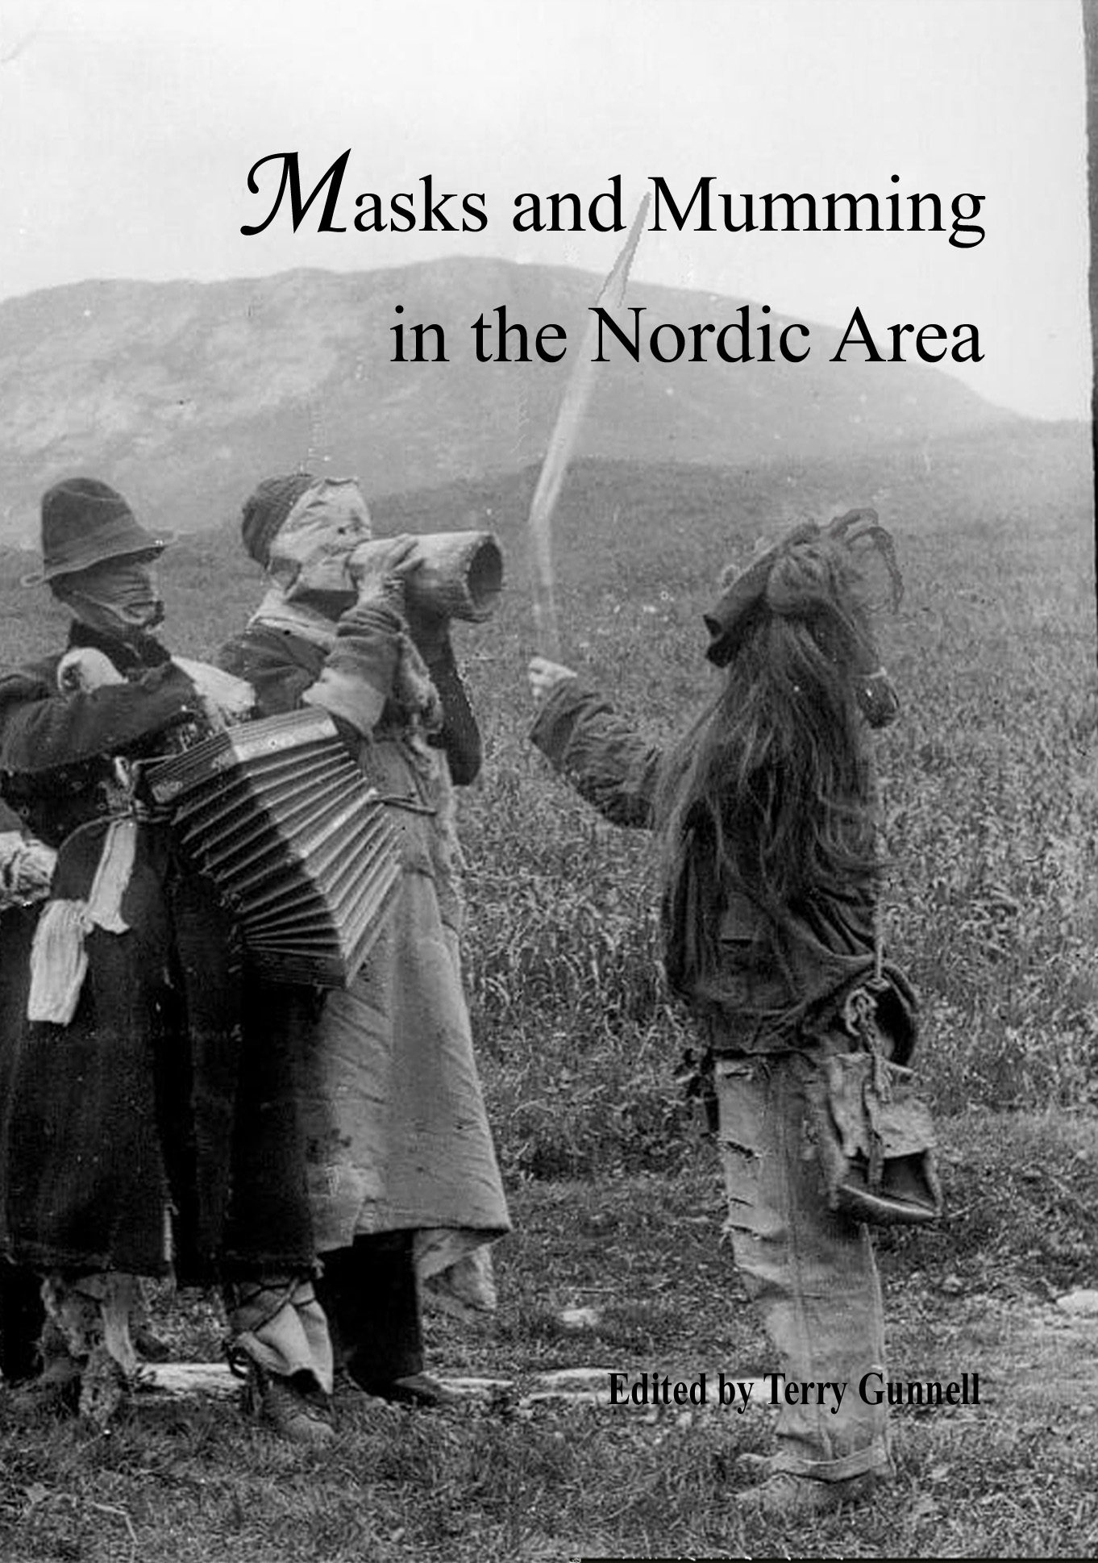

(Published by The Royal Gustavus Adolphus Academy for Swedish Folk Culture)

There has been a long-standing, widespread misunderstanding that traditional mask and mumming traditions are something that belong predominantly to the south and the “primitive”, and that the “cold and rationalistic” Protestant countries of the north had no form of theatre until comparatively recent times. Another misconception is that all early dramatic cultural expressions in the Nordic area were adopted from the countries to the south. To a large extent, these concepts stem from the fact that most research work into Nordic mumming traditions past and present has been written in the Nordic languages, and thus been inaccessible to many English speakers. As the surveys and case studies contained in this book show, the mumming or guising traditions of the Nordic area, running from Greenland to Orkney and Norway to Finland and Estonia, actually have deep and firm roots, many of which appear to go back to medieval if not pre-Christian times, and are still reinventing themselves in the present day. This volume (840 pages in length) is the work of twenty-three scholars. In addition to seven detailed surveys of the traditions of each area, it contains eighteen case studies offering different ways of dealing with material of this kind. All of the above are richly illustrated with new maps and a wide range of illustrations of Nordic mumming traditions past and present. The project is based on a NOS-H supported project which began in 1999. It is hoped that it will be an inspiration to others in various fields to go further into this intriguing subject and fill in any gaps that may have gone unnoticed. If nothing else, the book should alter the image of the “dour” inhabitant of the Nordic countries.

Special conference/ society offer:
SEK 300 / € 32 / £ 22 / $ 43 (until the end of 2007)
(published price: SEK 345 / € 38 / £ 25 / $ 50)

(Order form: see over)
Masks and Mumming in the Nordic Area
(ACTA ACADEMIAE REGIAE GUSTAVI ADOLPHI 98)

ORDER FORM

To: The Swedish Science Press, Box 118, SE-751 04 Uppsala, Sweden
(e-post: info@ssp.nu; telefax: +46-(0)18-365277)

Please supply _____ copy/ copies of Masks and Mumming in the Nordic Area at SEK 300 / € 32 / £ 22 / $ 43 (delete as applicable).

The postage for a single copy: Sweden: SEK 71; Europe: € 21 / £ 14 / $ 28 (delete as applicable); US: $ 35; rest of the world: € 26 / £ 17 / $ 35 (delete as applicable).

Do not pay in advance. Invoice will be sent together with the book.

Name: _________________________________________________________________________

Address: ________________________________________________________________________

_______________________________________________________________________________

Signature: ________________________________________________________________________

e-mail address: __________________________________ @ ______________________________

When ordering by phone, e-mail, or fax, please quote this special offer: MASKS AND MUMMING OFFER 2007

Kungl. Gustav Adolfs Akademien för svensk folkkultur
(The Royal Gustavus Adolphus Academy for Swedish Folk Culture)

